Picnic Performance!

NORTHVIEW BAND, ORCHESTRA, CHOIR, & THEATRE FAMILY PICNIC
You are cordially invited to the Annual Band, Orchestra, Choir, & Theatre Family Picnic on Tuesday, August 16th, on the “Hill”. A potluck dinner will be served at 6:00 P.M. Our Band and Orchestra Boosters will provide hot dogs, soft drinks, and table service. Families are asked to bring a dish to share according to last name:

A-G- Salad Dish H-P- Desert Dish R-Z- Vegetable Dish

A brief performance by the Wildcat Marching Band will begin at 7:15 P.M followed by a Summer Musical preview. You may wish to bring blankets or lounge chairs.

CHECK OUT THE SPECIAL EVENTS!

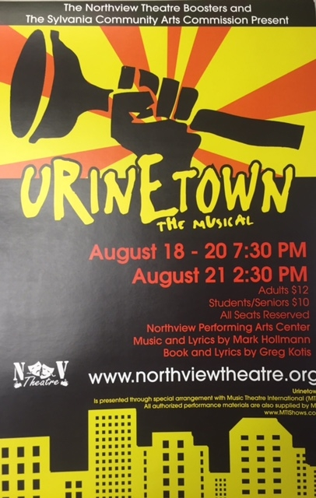

Sylvania Arts Commission & the Northview
Theatre Boosters proudly present:

Urinetown: The Musical
NV Performing Arts Center

Thursday, August 18th 7:30pm
Friday, August 19th 7:30pm
Saturday, August 20th 7:30pm
Sunday, August 21st 2:30pm

Tickets: Adult $12/ Student $10

