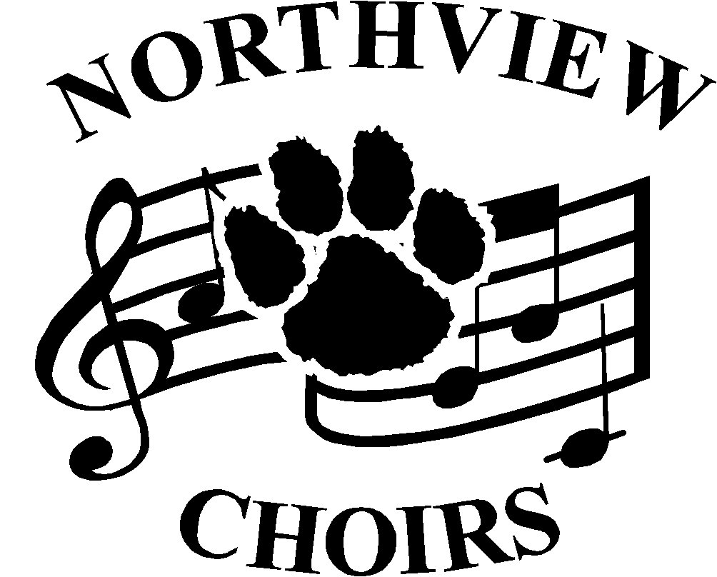
Welcome to the Northview Choirs!
nvchoirs.weebly.com

Join us at Wildcat Welcome Days in the Choir Room
Monday, August 8th, Seniors 2-4, Freshman 4-6
Tuesday, August 9th, Juniors 2-4, Sophomores 4-6

1) Register and Pay Choir Fees in Aux Gym (Cash or Checks payable to Northview Choir Boosters)
•Concert attire maintenance fee- $25- All Members
•Choir T-Shirt- $10- All Members
•A Cappella Women’s jewelry (required if you don’t have already) - $15

2) All Ladies: Get Measured for Concert Shoes in the Aux Gym
•Women’s concert shoes (required if you don’t have already) $37.38 – checks only payable to Opening Night ($43.97 in-store price; 419-536-3202)

A Cappella Men Only: Get Measured for Concert Shoes and Tux Shirts in the Choir Room
Men’s concert shoes- $27.70 (Ordered at Rettigmusic.com- See back for ordering instructions)
Tuxedo Shirt- $14.00 (NV Choir Boosters)

3) Stop in the main office to pay your $50 Pay-to-Participate fee (cash or check to Sylvania Schools)
Separate fee for each activity that your student is involved in, check with the office for details.

If you are unable to register during WWDs, please complete the registration form below and mail it with the appropriate fees (check made payable to Northview Choir Boosters). You must also visit Opening Night (ladies)
3159 W. Central Ave, Toledo in the Cricket West Shopping Center to get fitted for shoes. A Cappella men will need to be measured for a tux shirt by Friday, September 2nd.
*Due Date for all forms and fees is Friday, September 2nd*
----------------------------------------------------------------------------
Registration Form – please return this portion along with payment during Wildcat Welcome Days or mail to: Northview Choir Boosters, PO Box 773, Sylvania, OH 43560

Student name (print): __________________________________Grade: ____ Contact phone: __________________

Contact email: Choir (circle all that apply) Men’s Women’s A Cappella Road Show

Please complete the following:

Address: _______________________________________________ City:___________________ Zip:__________

Mother’s name: _______________________Contact phone#: ______________Email: _________________________

Father’s name: ________________________Contact phone#: ______________Email: ________________________

Fees required - please fill in amounts due:
•Concert attire maintenance fee- All Members- $25 ___$25__
•A Cappella Men’s Tuxedo Shirt- Only new A Cappella Men- $14 ________
•Travel Shirt- All Members- $10- (circle size needed): S M L XL 2XL ___$10__

Orders, for shirts and jewelry, after September 8th, will be subject to an additional $5 special order fee.
•A Cap Women’s jewelry (required if you don’t have already) $15 (Please circle type): pierced clip ______

Cash_____ or Check#_______ (payable to Northview Choir Boosters) Total Amount Due: ______
Total Amount Paid: ______

Instructions for ordering A Cappella Men’s Tuxedo Shoes

- Go to www.rettigmusic.com
- Select “Shop” & scroll down to select “Shop by School”
- Scroll down to select “Sylvania City Schools”
- Select “Choir”
- Select “Formal Shoes- Black- Men’s”
- Select Required size and then “add to cart”
- Select “View Cart”
- Select “Proceed to checkout”
- Complete all the shipping & Payment method information and click “Place Order”

