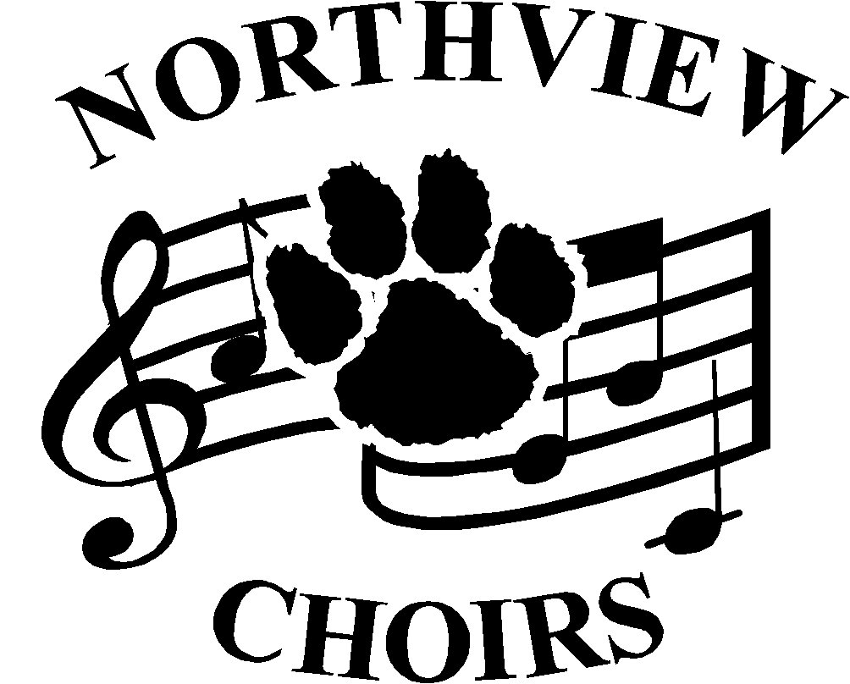
NV Choirs’ Registration Checklist

*Make checks payable to names in parentheses*

All Choir Members
___ Register/Update personal information on Charms Website. (See Mr. Davis in the Aux Gym)
___ Pay $35 uniform maintenance fee/T-shirt fee
(NV Choir Boosters)
___ Pay $50 Pay to Participate (Sylvania Schools- Pay in
Main office)

A Cappella Choir Men- Wildcat Welcome Days
___ Get fitted for Tux Shirt- Aux Gym
___ Pay $14.00 for Tux Shirt (NV Choir Boosters)
___ Pay $27.70 for Tux Shoes (Paid online-Rettigmusic.com)

A Cappella Choir Women- Wildcat Welcome Days
___ Get fitted for Concert Shoes- Aux Gym
___ Pay $15.00 Jewelry Fee- (NV Choir Boosters)
___ Pay $37.38 for Concert Shoes (Opening Night)

Women’s Chorus Members- Wildcat Welcome Days
___ Get fitted for Concert Shoes- Aux Gym
___ Pay $37.38 for Concert Shoes (Opening Night)

Men’s Chorus Members- Wildcat Welcome Days
- No steps besides the All Choir steps listed above are required.

NV Choirs’ Registration Checklist

*Make checks payable to names in parentheses*

All Choir Members
___ Register/Update personal information on Charms Website. (See Mr. Davis in the Aux Gym)
___ Pay $35 uniform maintenance fee/T-shirt fee
(NV Choir Boosters)
___ Pay $50 Pay to Participate (Sylvania Schools- Pay in
Main office)

A Cappella Choir Men- Wildcat Welcome Days
___ Get fitted for Tux Shirt- Aux Gym
___ Pay $14.00 for Tux Shirt (NV Choir Boosters)
___ Pay $27.70 for Tux Shoes (Paid online-Rettigmusic.com)

A Cappella Choir Women- Wildcat Welcome Days
___ Get fitted for Concert Shoes- Aux Gym
___ Pay $15.00 Jewelry Fee- (NV Choir Boosters)
___ Pay $37.38 for Concert Shoes (Opening Night)

Women’s Chorus Members- Wildcat Welcome Days
___ Get fitted for Concert Shoes- Aux Gym
___ Pay $37.38 for Concert Shoes (Opening Night)

Men’s Chorus Members- Wildcat Welcome Days
- No steps besides the All Choir steps listed above are required.

