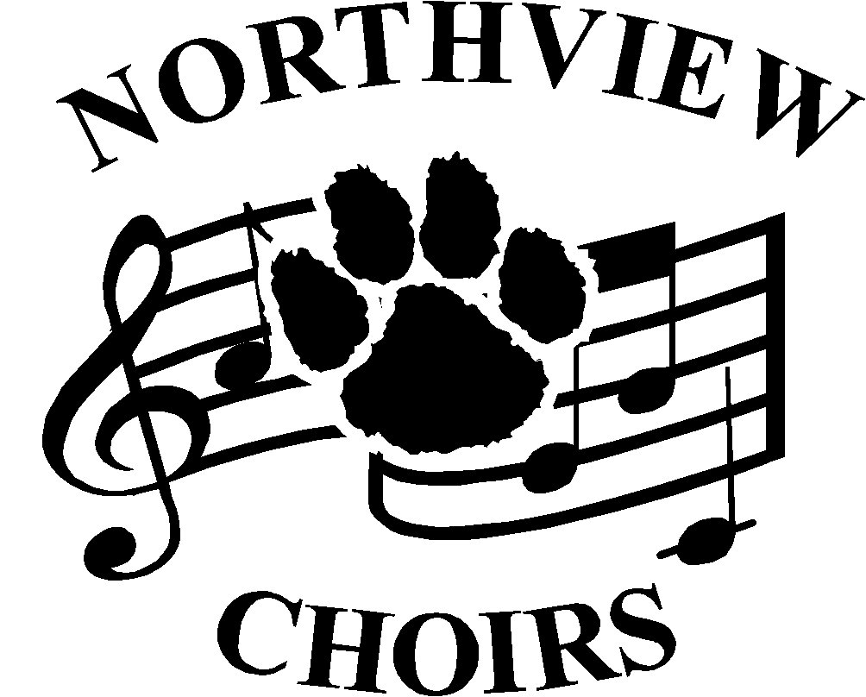
Choral Activities
Jeremy Davis, Director
5403 Silica Dr. Sylvania, OH 43560
(419) 824-8570 ext. 5127
nvchoirs.weebly.com
jdavis@sylvaniaschools.org

August 15, 2016

Dear Parent or Guardian,

I ask that each student and his/her parent read this handbook and review the calendar of concert dates thoroughly. This handbook is designed to create a clear understanding of the expectations and responsibilities of each choir member and his/her parents. It takes a willingness to work together, positive attitudes, discipline, and open lines of communication between everyone involved to make a successful music program. Please review it carefully and contact me with any questions. We can be proud of the Northview Choral Department and its outstanding tradition of excellence. We will continue to work together to make our groups the highest quality possible and a source of pride for the entire community. I am very proud to serve as your director and I am looking forward to an exciting year!

Sincerely,

Jeremy Davis
Sylvania Northview Choral Director

*After reading this handbook, please fill out and sign the attached Commitment Form to Mr. Davis by Friday, September 2nd.

The purpose of this handbook is to acquaint choir students and their parents with all the aspects of membership in the choirs. Read and keep this handbook in your personal binder. It is my hope that the information included will make participation more enjoyable and rewarding.

About the Choirs
For the 2016-17 school year Sylvania Northview High School will consists of four choirs, all of which are taken as classes during the day: A Cappella Choir, Women’s Chorus, Men’s Chorus, and Harmony Road Show.

A Cappella Choir
For the 2016-17 school year the A Cappella Choir will consist of auditioned male and female voices grades 10-12. Auditions for the A Cappella Choir are held in the early spring for the following school year. The A Cappella Choir performs some of the most challenging literature from the choral repertoire and consistently scores excellent and superior ratings at OMEA state-level adjudicated events.

The Choir meets during regular class time five days a week. In addition, students are expected to attend Sectional Rehearsals at times set by the section leaders. During even numbered years, the A Cappella Choir performs a “Cat’s Café” in February. Choir members create the atmosphere of a 1950’s diner while serving and performing for their guest. During non-Cat’s Café years, the A Cappella Choir tours New York City for three days over spring break. Tour combines a challenging performance schedule with sightseeing and cultural events. March and April/May are contest months, with the A Cappella Choir participating in the OMEA District Contest. By scoring a “1”, the choir advances to State Competition. May features the Spring Concert with all of the Northview Choirs.

In addition to the traditional concerts, the A Cappella Choir is frequently invited to sing with other professional musicians and at community functions. The A Cappella Choir has performed with the Toledo Symphony, Cincinnati Opera, BGSU’s & UT’s Choirs and for the Sylvania Rotary and Chamber of Commerce. In any given year, the A Cappella Choir performs several additional concerts by invitation.

Men’s and Women’s Chorus
The Northview Men’s Chorus and Women’s Chorus are mid-level auditioned ensembles composed of male and female students in grades 9-12. The Men’s Chorus and Women’s Chorus performs moderately difficult music ranging from classical to spirituals and novelty numbers. Throughout the year these choirs focus on honing their sight-reading skills and developing solid vocal technique. They traditionally perform in shared concerts with the A Cappella Choir and Harmony Road Show in October, December, March, and May. In addition, they will compete in District contest and also go to State Competition if a score of “1” is achieved at District Contest.

Harmony Road Show
Specializing in vocal pop, Harmony Road Show (“HRS”) is a mixed voice audition-only group of 16 singers. Membership must be concurrent with membership in A Cappella Choir. Students learn vocal pop performance techniques as they sing into their own microphone. They are expected to learn about vocal sound technology and tech set-up of speakers and microphones in various performance venues. HRS performs by invitation at many community functions, at choir concerts, and with the Northview Jazz Band in the spring. The Harmony Roadshow has performed and work shopped with members of M-Pact, Up-in-the-Air, New York Voices, and vocal jazz/vocal pop professionals from around the world.

Purpose of Sylvania Northview Choirs
- To promote the highest possible standards of excellence in performance, pride, and professionalism in oneself, the choir, the school, and the community.
- To provide a constructive and beneficial activity for student participation.
- To encourage school spirit and pride.

Concert Attendance and Absences
- A public performance of the music rehearsed in class is looked upon as a final test. Therefore, students are required to participate in all functions of the choir in which he/she is a member.
    - An unexcused absence from a performance without prior notice to the director will result in zero for concert participation.
    - An excused absence is when a student is unable to attend a performance and has given the director TWO WEEKS notice. For all excused absences, students must compete the following assignment to receive full performance credit:
Alternate Assignment: Prior to the performance date, students must record themselves during rehearsal, via their charms account. To receive full credit, students must record a majority of each selection being performed on the missed concert and demonstrate proper pitch, rhythm, and tone. This assignment may be completed during rehearsals or on the students own time.
    - An emergency absence because of a personal illness, death in the family, or other emergency can be excused with a note from a parent to the director. To receive full credit for the missed concert, students must schedule a meeting with Mr. Davis. During this meeting students will perform each selection performed on the missed concert. Students must demonstrate proper pitch, rhythm, memorization, and tone to receive full credit for the missed performance.
    - Students must attend 3 of the final 5 rehearsals prior to a performance to participate. In situations where a student is withheld from a performance based on attendance, the absence will be treated as an emergency absence (iii.). The student must schedule a meeting with Mr. Davis to perform their ensemble’s music selections.

Grading and Expectations
- 50% of the 9 weeks grade will be based on Daily Participation. Each student will begin each quarter with a 100% participation grade. Students will maintain their 100% by doing the following:
    - Being on time for class.
    - Participating in warm-ups, vocalizing, and singing.
    - Refraining from distracting others and/or not working on task, which includes cell phone distraction.
    - Not talking during rehearsals unless called upon to do so.
    - Completing all required vocal tests and recordings.
    - Having a POSITIVE attitude toward other choir members, new music, musical concepts, and director.
If a student is unable to accomplish one of the above objectives points will be deducted from their nine weeks grade.
- 40% of the 9 weeks grade will be based on Concert Requirements. There will be a concert every 9 weeks. Concert attendance and participation is mandatory. Please make certain you mark down your concert calendar dates. Unexcused absences will result in a zero. (For questions regarding absences see Concert Attendance and Absences) Behavior at concerts will also affect this portion of the student’s grade. Students will be instructed on proper concert etiquette and will be expected to behave accordingly.

- 10% of the 9 weeks grade will be based upon Charms recording assignments. Each quarter students are required to submit a recording on Charms. Assignments will be give during class.
    - Grades will be computed on the following scale:
A=91%-100%
B=81%-90%
C=71%-80%
D=61%-70%
F=60% and below

STUDENTS MAINTAINING AN AVERAGE LESS THAN 91% MAY BE WITHELD FROM PERFORMANCES AT THE DIRECTOR’S DISCRETION.

Honors Program
11th and 12th grade students may take A Cappella Choir for Honors credit with the approval of the instructor and by meeting the following guidelines each quarter an Honors grade is attempted:
- Student is taking private lessons and receives a “good” or “excellent” evaluation for the quarter.
- Student is studying Class “A” literature for the soloist.
- Participation in Solo/Ensemble contest at the Class “A” level is required.
- An honors project is required for each quarter that an honors grade is attempted. Students must see the Director for a list of suggested projects and have the project approved by the Director before submitting the project.

Choir Trips
- All members must have current Emergency Medical Authorization Forms on file with school office.
- All school rules apply on trips at all times.
- All students ride the bus to and from choir functions. A Student will be permitted to ride home from a function when his/her parent submits a school “personal transportation” form to the choir director at least one day in advance.
- Departure times for each trip will be announced. Plan on being 20 minutes early in order to load and organize.

BE WHERE YOU NEED TO BE, WHEN YOU NEED TO BE THERE, WITH EVERYTHING YOU NEED!

Concert Attire

A Cappella Choir
Care of your concert attire is your responsibility. Choir uniforms are stored in garment bags in the uniform storage room. You must remember to bring your undergarments and jewelry to concerts.
- Always store your clothing in the garment bag, and hang it up at all times.
- Performance jewelry should be stored in the drawstring bag, and kept inside the garment bag. Men should keep their ties in the inside pocket of their tux.
- Keep your shoes in your garment bag.
- No cologne, perfume, or after-shave.
- Hair must be pulled back off the face so it cannot fall on the face.
- No jewelry (watches, etc.) other than that which is part of the concert attire.
A Cappella Women
1. One-piece costume consisting of a floor-length black dress.
2. A pearl necklace and pearl earrings must be worn with the black dress. (Pierced or clip earrings are available through the choir boosters.)
3. Black sheer hosiery (no opaque, no flesh tone hosiery)
4. Black concert shoes
5. Black lingerie.

A Cappella Men
1. Tuxedo, consisting of black jacket, black pants, white tuxedo shirt
2. Black cummerbund and black bow tie
3. Shirt studs and cuff links
4. BLACK SOCKS!
5. Black concert shoes
6. A white undershirt is highly recommended to protect the tux shirt.

Men’s Chorus and Women’s Chorus
Choir robes are stored in garment bags in the choir room. You must remember to bring your shoes, socks, and hosiery to a concert.
- Black choir robe with gold cowl
- Choir T-shirt
- Black dress pants
- Black concert shoes (Women will wear approved concert shoes from Opening Night)
- No jewelry (including decorative hair jewelry/scarves) is to be worn with the choir robes
- No perfume, cologne, or after-shave
- Hair must be pulled back off the face so it cannot fall on the face.

Casual Attire
Occasionally, a concert will be “casual” (announced in advance). Students wear their choir t-shirts with blue jeans. You are representing Northview High School, and it is important to wear your choir shirt with pride. Choir shirts are to be worn tucked in from the time the choir leaves Northview until the choir returns to school. No hats are allowed at any time when participating in a choir function.
(Members without proper attire WILL NOT participate.)
Fees and Obligations
- All students are required by the Sylvania Board of Education to pay a $50 “Pay to Participate” fee. Checks payable to Sylvania City Schools. Pay to Participate checks should be given to Mrs. Ragland in the main office.
- All students are required to pay a costume maintenance fee, which covers dry-cleaning and repairs. The maintenance fee for all choir members is $25.
- Students are required to own a “choir t-shirt” for casual concerts. The shirt costs $10.
- All A Cappella men and all women must own approved concert shoes. Men’s shoes are purchased through www.rettigmusic.com and cost $37.38. Women’s shoes are purchased through Opening Night and cost $43.97 and up, depending upon size. All-leather shoes are available through Opening Night and are $55 and up.
- Men in A Cappella Choir are required to purchase a tuxedo shirt through the NV Choir Boosters, at a cost of $14.00.
- Women in A Cappella Choir are required to purchase a pearl necklace and earrings through the NV Choir Boosters, at a cost of $15.00. Pierced or clip earrings are available.
- Replacement costs for lost or damaged music and/or costumes will be assessed.

OUTSIDE THE CLASSROOM INFO…

Competitions and Contests

“Ohio Music Educators Association” Adjudicated Events

- District I Large Group (Choir) Contest
The A Cappella Choir, Men’s Chorus, Women’s Chorus, Symphonic Choir, and the Northview Women’s Chorus all participate in “District I” Choir Contest. District I is comprised of six counties in Northwest Ohio. Choirs enter District Contest within categories according to the level of difficulty of performance pieces. There are four performance levels: “C,” “B,” “A,” and “AA,” with the “C” level being the easiest or beginning category and “AA” being the most difficult. Class “D” is a “comments-only” class. Participating choirs at all levels of entry each perform three pieces of choral music and are also judged on sight-reading. A choir achieving a composite score of “1” at District Contest is invited to compete at the state level.

- State Large Group (Choir) Contest
Choirs receiving a score of “1” at the District level, advance to State Competition. The format at the State level is identical to District judging.

- Solo and Ensemble Contest
Individual members of the choral music program may choose to participate in “Solo and Ensemble Contest.” Soloists choose their performance music with the assistance of the Choral Director or their private music instructor. Students may also wish to compete as an “ensemble.” Women’s ensembles vary in size from 3 to 9 singers, and men’s ensembles range from 4 to 9 singers. Mixed groups (men and women) range from 4 – 24 singers. Participation in Solo and Ensemble Contest is mandatory for Honors Students and while optional, is encouraged for any other choir student.

The Northview Choir Booster Club

The Northview Choir Booster Club is an organization of parents and interested community members who actively support choral music in the Northview Community. There are no dues, and all parents are welcome at all meetings and Booster Club functions. The Booster Club meets the 2nd Monday of every month. Meetings are at 7:00 p.m. in the Choir Room. Election of officers is held at the annual meeting in May, which is part of the Awards Banquet.

The Choir Boosters support all choirs at Northview primarily in two ways: financial support and volunteer support.
Volunteer Support
Volunteers are the heart of the Booster Club. All parents are welcome to participate in Booster Club activities and are encouraged to become involved.

- Chaperones are needed an all school busses. When any choir performs away from Northview, at least 2 adults should ride every student bus. Some performances are during the school day, and some on the weekends.
- Baking and Food Preparation. The Booster Club provides food for special events and performances. For example, when a choir visits Northview, we serve baked goods, coffee, and juice. The spring concert features a reception, and the Booster Club donates food items.

- Registration. The two days of schedule pickup at Northview also involve collecting choir fees and fitting costume attire in the choir room.

- Sewing and costume maintenance. Volunteers sew and design all Chamber Costumes and Madrigal Dinner costumes. At registration volunteers fit choir members’ Dresses, Tuxedos, and Robes. Volunteers need not have special skills – just enthusiasm for the job. Please provide your own tape measure & straight pins.

- Communications.Because our choirs are very active, maintaining timely communications with families and the community is essential. The Booster Club publishes The In-Choirer four times a year and also maintains a phone committee.

- Public Support. We welcome and encourage you to come to all choral music performances and to bring family members and friends. Audience support is vital to the performance aspect of choral music education.
Financial Support
The Booster Club contributes approximately $20,000 annually to the Choir Program. These funds go directly to the students and the choir program in the form of scholarships, music and equipment purchases, costume and concert-wear purchases, and learning tapes and materials. Large capital items, such as risers and sound equipment, are also purchased by the Choir Boosters and donated to Northview.

- Sponsorships. Fundraising volunteers actively solicit both individual and business sponsorships. Gifts at any donation level are welcome, and we show our gratitude by recognizing all sponsors in concert programs, The In-Choirer, and by display boards. Donations throughout the year will help our choirs maintain their status among the top choirs in the state.
- Advertising. Vendors and choral supporters may purchase advertising space in every program.
- Fundraisers. Throughout the year, the Booster Club sponsors various fundraisers. Fundraisers vary from year to year, and will be decided in the fall.

- Kroger Cares: The use of a Kroger gift card encoded to the choir allows the booster organization to receive 5% of all purchases made at Kroger. This program could help the boosters eliminate the need for extra fund-raisers throughout the year. Kroger “Choir” gift cards can be “refueled” using cash, check or credit card at any Kroger Customer Service Desk.

- Underwriting. Special projects, such as the choral CD project, are funded through underwriting by individuals and corporations.

- Special Projects. From time to time, the Booster Club sponsors projects that focus on community good will. The Booster Club welcomes any and all fundraising suggestions and community good will projects.

7. The Endowment Fund
The Endowment fund has been established as a long-term investment fund to benefit the choral music program. As with all endowed funds, the principle can never be spent. Dividends/interest from the principle can be used for the choral touring funds and for scholarship. This is the type of gift that will continue to give perpetually.

Literature Selection Policy
As a choral musician, it is necessary to be tolerant of other religions and to treat the singing of religious music as a performance. The art of singing in four-part harmony and even our system of writing music was developed by the Roman Catholic Church and is a tradition of Western Civilization. So while it is historically true that the Christian religion has been a major source of inspiration for much of the world’s great music, is music, religious differences can become points of understanding between people. Jewish Synagogue canting became Gregorian chants of the early Christian Church, and Hebrew folksongs are some of the most beautiful melodies ever sung. George Frederick Handel, the court composer of King George I of England and composer of The Messiah (considered one of the greatest choral works ever written), also wrote an oratorio called Judas Macabeus which is based on the Old Testament hero of the Hebrew people.

There is often controversy over singing choral music due to the text, and while some would wish to censor what the choir sings, the Music Department in conjunction with the Sylvania School District and community leaders has adopted a very clear policy concerning the choral curriculum. In keeping with that policy, that Northview Vocal Music Program will always include a variety of musical subject matter including some pieces which have been religiously inspired.

Music is selected on the basis of the highest standards for teaching musical independence (reading) and choral performance, and is programmed with the audience in mind. Much of the literature is chosen directly from the Ohio Music Education Association (OMEA)’s contest lists. This list has grown to include multicultural pieces by non-American composers. Others are from standard or “classic” choral repertoire heard at performances and educational conference or by community or student suggestion. Much attention is given to singing American choral literature including African American spirituals, jazz, and tunes of the American Musical Theatre.

While every person is entitled to his or her opinion, discussion of personal preferences or religious beliefs has no real place in the choral classroom. It is the responsibility of the choir director to select music that is appropriate for the students’ academic needs, understanding, and musical ability. It is the duty of the choral performer to learn that music to the best of his or her ability and to perform it for the benefit of an audience.
Northview choirs will perform an array of music from diverse time periods and cultures. While each performance may not be authentic, it is understood that performances and rehearsals will be culturally sensitive and respectful.

