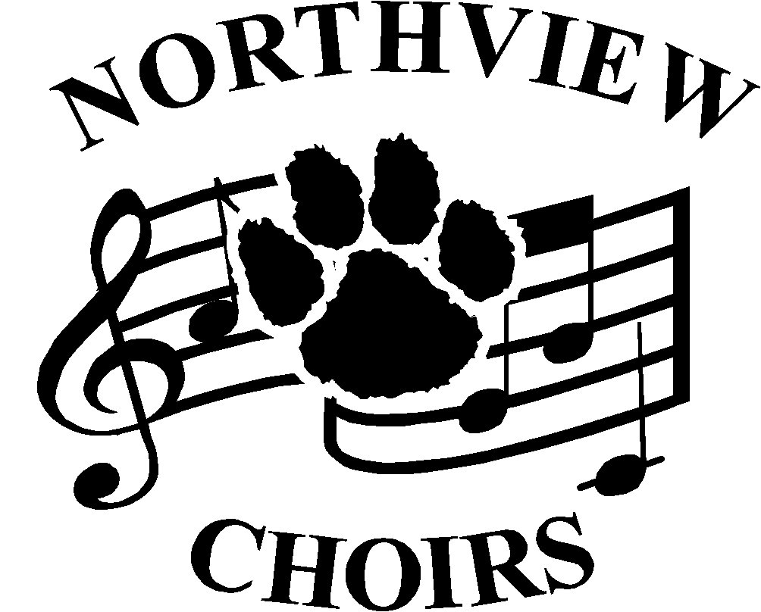
Choral Activities
Jeremy Davis, Director
5403 Silica Dr. Sylvania, OH 43560
(419) 824-8570 ext. 5127
nvchoirs.weebly.com
jdavis@sylvaniaschools.org

August 1, 2016

Dear Parent or Guardian,

Welcome to another exciting year as a member of the Northview Choral Department. If your student is a first time member, I can assure you Northview Choir is a truly rewarding musical experience that provides students not only the opportunity to perform in superb vocal ensembles, but also memories they will carry with them for a lifetime. I am extremely proud to be the director of the Northview Choral Department and I’m ready for another exciting year!

Charms
Charms is the online organizational system we use to organize our entire choral department. Please make sure your student is registered and your contact information is up to date. There are detailed instructions included with this packet to help with your student registration.

Website
The Northview Choral Department’s website is nvchoirs.weebly.com. Please take a minute to view and let us know what you think.

Choir Boosters
Choir Booster meetings are held the second Monday of every month at 7pm in the choir room. Please feel free to attend and share your thoughts and opinions.

As always, please feel free to contact me with any questions and concerns.

All the best,

Jeremy Davis
Sylvania Northview Choral Director

